**Internet notes**

**Studying Backend**

|  |
| --- |
| **Link:**  *https://www.cloudflare.com/learning/network-layer/how-does-the-internet-work/#:~:text=Computers%20connect%20to%20each%20other%20and%20to%20the%20Internet%20via,interpreted%20by%20the%20receiving%20computer.* |

**What is a network?**

A network is a group of intersconnected computers that are able to send information to one another, the article draws a parallel with the network and social circles- it says a network is much like a social circle where a group of people all know each other and share information, and coordinate activities together.

|  |
| --- |
| **Easy to overlook:** Internet quite literally means *interconnected networks.* |

**What is the internet?**

Computers are all connected to said network so they are able to communicate with each other.

|  |
| --- |
| All data sent over the Internet is translated into pulses of light or electricity, also called “bits”, and then interpreted by the receiving computer. The wires, cables and radio waves conduct these bits at the speed of light. The more buts that can pass over these wires and cables at once, the faster the Internet works. |

**What is distributed networking?**The article tells me that there is no control centre for the internet. Instead, it is a distributed networking system, meaning it is not dependent on any individual machine.

|  |
| --- |
| **Cool analogy:**  Computer, servers, and other pieces of networking hardware connect and disconnect from the internet all the time without impacting how the Internet functions- unlike a computer, which may not function at all if it is missing a component. This applies even at a large scale: If a server, an entire data centre, or an entire region of data centres go down, the rest of the Internet can still function (if more slowly). |

**How does the internet work?**  
Apparently there are two main concepts which are fundamental to the working of the Internet:

* **Packets**
* **Protocols**

**What are Packets?**  
In networking, a packet is a small segment of a larger message. Each packet contains both data and information about said data.

The information about the packet’s contents is known as the “header” and it goes at the front of the packet so that the receiving machine knows what to do with the packet.

|  |
| --- |
| **Packets in relation to the internet**  When data gets sent over the Internet, it is first broken into smaller packets, which are then translated into bits and the packets are routed to their destination by various networking devices such as routers and switches. When the packets arrive at their destination, the receiving device reassembles the packets in order and can then use or display the data.  **Cool analogy:**  *Compare this process to the way the United States' Statue of Liberty was constructed. The Statue of Liberty was first designed and built in France. However, it was too large to fit onto a ship, so it was shipped to the United States in pieces, along with instructions about where each piece belonged. Workers who received the pieces reassembled them into the statue that stands today in New York* |

**Packet switching**

|  |
| --- |
| **Link:** *https://avinetworks.com/glossary/packet-switching/#:~:text=Packet%20switching%20is%20the%20transfer,faster%2C%20more%20efficient%20data%20transfer.* |

“Packet switching is the transfer of small pieces of data across various networks. These data chunks or “packets” allow for faster, more efficient data transfer.”

|  |
| --- |
| **Cool info** The header of a packet usually includes the origin IP address, the destination IP address, the number of packets in the entire data file, and the sequence number (*The sequence number of a packet is a counter that tracks the bytes sent by a host in a Transmission Control Protocol (TCP) connection*) |

|  |
| --- |
| **Cool concept** These packets are sent separately and processed by routers and switches along the way. Each piece is handled individually, without worrying about where it came from or where it’s going. This is done to prevent any one connection from using too much of the network at once.  Apparently if no packet switching occurred- just a connection between two computers would occupy multiple cables, routers, and switches for minutes at a time and only two people would be able to use the internet at a time. |

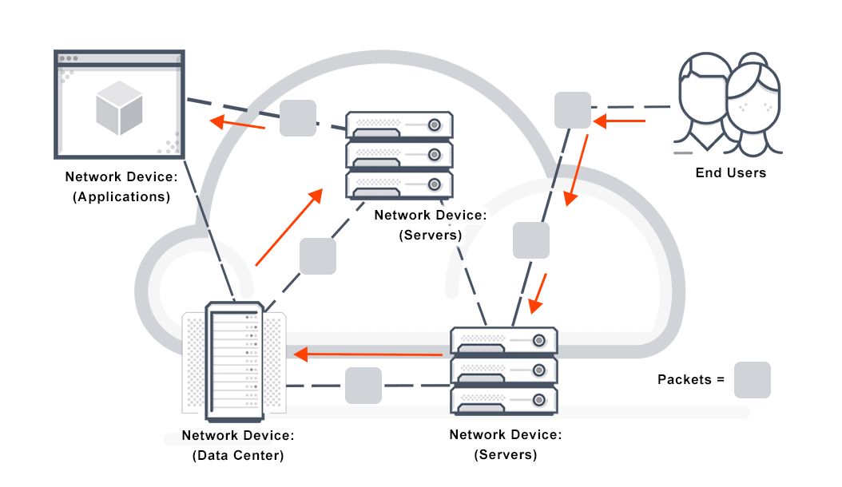

**What are protocols?**

|  |
| --- |
| **Cool analogy** *“Connecting two computers, both of which may use different hardware and run different software, is one of the main challenges that the creators of the Internet had to solve. It requires the use of communications techniques that are understandable by all connected computers, just as two people who grew up in different parts of the world may need to speak a common language to understand each other.”* |

The above problem is solved with the use of standardized protocols. Protocols are the standardized way of doing certain actions and formatting data so that two or more devices are able to communicate with and understand each other.